Create a dashboard in Power BI for Claire that reflects all relevant Key Performance Indicators (KPIs) and metrics in the dataset. Get creative!

**Possible KPIs include (to get you started, but not limited to):**

* Overall customer satisfaction
* Overall calls answered/abandoned
* Calls by time
* Average speed of answer
* Agent’s performance quadrant -> average handle time (talk duration) vs calls answered

In addition, to better understand the data, the telecom Retention Manager has scheduled a meeting with the engagement partner at PwC to cover these points:

* Customers in the telecom industry are hard-earned: we don’t want to lose them
* The retention department is here to get customers back in case of termination
* Currently, we get in touch after they have terminated the contract, but this is reactionary: it would be better to know in advance who is at risk
* We  have done customer analysis with Excel: it has always ended in a dead-end
* We would like to know more about our customers: visualised clearly so that it’s self-explanatory for our management

The Retentions Manager has provided some information in the resources.

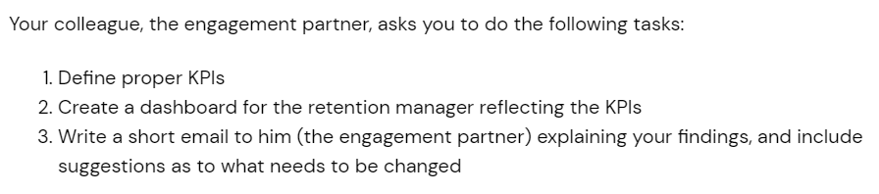

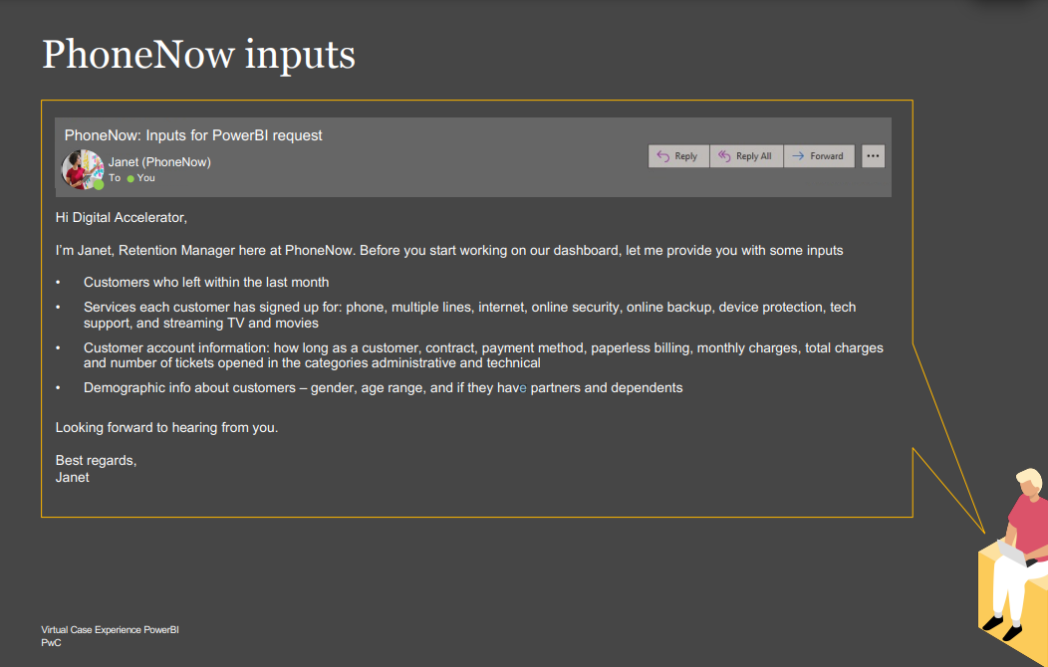

# **Resume Snippet**

Take your updated resume and apply for Jobs , Programs , Events  and Talent Networks .

**PwC Switzerland Power BI Job Simulation on Forage - June 2024**

* Completed a job simulation where I strengthened my PowerBI skills to better understand clients and their data visualisation needs.
* Demonstrated expertise in data visualization through the creation of Power BI dashboards that effectively conveyed KPIs, showcasing the ability to respond to client requests with well-designed solutions.
* Strong communication skills reflected in the concise and informative email communication with engagement partners, delivering valuable insights and actionable suggestions based on data analysis.
* Leveraged analytical problem-solving skills to examine HR data, particularly focusing on gender-related KPIs, and identified root causes for gender balance issues at the executive management level, highlighting a commitment to data-driven decision-making.

# **Interview Tip**

In a typical interview you’ll be asked “why are you interested in this role?” or “why are you interested in working at our company?”. Use this interview tip to explain why you want the job.

**“Why are you interested in this role?”**

I recently participated in PwC's virtual job simulation on the Forage platform, and it was incredibly useful to learn about how to use PowerBI more effectively.

I practiced creating a Power BI dashboard for visualizing key performance indicators (KPIs) and metrics.

Doing this program confirmed that I really enjoy working with data visualization using Microsoft PowerBI for diversity and inclusion in the corporate world, and I’m excited to apply these skills at a company like PwC.